
MAY
Mo Di Mi Do Fr Sa So
4 5 6 7 8 9 10

24. Cycle day

Period of time in 6 Days


10:00 Puncture


20:00 Ovitrelle




MENU | CALENDER | TREATMENT PLAN | DIARY | ITEMS

MAY

Mo Di Mi Do Fr Sa So
1 2 3

4 5 6 7 8 9 10
PU
11 12 13 14 15 16 17

18 19 20 21 22 23 24

25 26 27 28 29 30 31

JUNE

MENU | CALENDER | TREATMENT PLAN | DIARY | ITEMS

Period of time
To edit





light medium strong

Sex



unprotected protected

Scheidenausfluss







no discharge spotting sticky creamy protein-like watery

Mood





happy depressed relaxed irritated sad


Mood swings

Symptoms






Tender breasts abdominal pain headache back pain







Craving’s nausea vomiting skin blemishes tiredness






Insomnia constipation diarrhea flatulence

ovulation




Positive negative own method

Pregnancy test




positive negative pale line

Weight
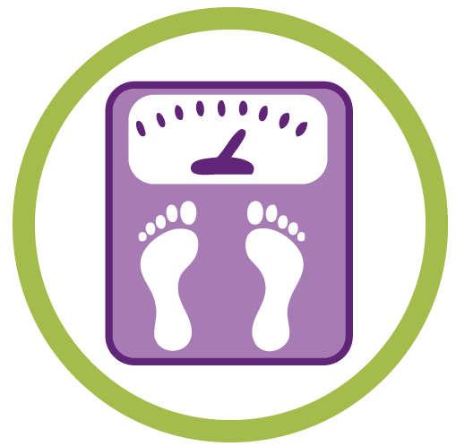

- - : - - kg

Diagram

Basaltemperatur


- - , - - ºC

Diagramm

MENU | CALENDER | TREATMENT PLAN | DIARY | ITEMS
Diagram basal temperature scale 35.00 to 38.50

Selected period ◄ 12.4. - 11.5.2020 ►

38.50---------------------------------------------

38.00---------------------------------------------

37.50---------------------------------------------

37.00---------------------------------------------

36.50---------------------------------------------

36.00---------------------------------------------

35.50---------------------------------------------

35.00---------------------------------------------
12 14 16 18 20 22 24 26 28

MENU | CALENDER | TREATMENT PLAN | DIARY | ITEMS

Diagramm Gewicht Skala 45 kg bis 200 kg

Gewählter Zyklus ◄ 12.4.-11.5.2020 ►

115-------------------------------------------------

105------------------------------------------------

95-------------------------------------------------

85-------------------------------------------------

75-------------------------------------------------

65-------------------------------------------------

55-------------------------------------------------

45-------------------------------------------------
12 14 16 18 20 22 24 26 28

MENU | CALENDER | TREATMENT PLAN | DIARY | ITEMS

